GCSE & GCE Examinations Summer 2023

Guidance for Students and Parents

Introduction

As you approach the challenge of public examinations this summer, we hope to make the experience as stress-free and successful as possible. Hopefully, this booklet will provide information that is helpful for you and your parents. Please read it carefully before exams begin, so that you are aware of the examination regulations, and the procedures to follow in the event of any problems occurring. The Awarding Bodies set down strict regulations for the conduct of examinations which must be followed precisely to avoid malpractice. All JCQ regulations and information about exams can also be found on the school website in Academic/ Examination Information.

The non-examination assessment (NEA) mark appeals procedure is also included, this is linked to internally marked coursework, practicals or speaking tasks. Your teacher will be giving you your NEA mark. You can appeal against this if you are unhappy with the way it has been marked. The internal deadline for appeals for most GCSE & A-Levels is Wednesday 3 May 2022 (Exceptions are AQA GCSE- 26 April & Eduqas GCSE- 23 April) so that we have time to review your appeal, prior to sending marks into the relevant Exam Board before their deadlines.

If you or your parents have any queries or need help or advice at any time before, during or after the examinations please contact:
Examinations Officer - Mrs Donna Lewis
The school telephone number is 01392 273417 (Exams Office – ext. 136)
Email: donnalewis@maynard.co.uk

Key dates:
A-level exams begin: Tuesday 16 May 2023
A-level exams end: Monday 26 June 2023

GCSE exams begin: Mon. 15 May 2023
GCSE exams end: Tuesday 20 June 2023
*Contingency Days: Thursday 8 & 15 June (afternoon) & Wednesday 28 June (All day)

A Level results: Thursday August 17 2023
GCSE results: Thursday August 24 2023

Maynard School
Reviews of marking - centre assessed marks
(GCE and GCSE non-examination assessments)
The following policy is linked to non-examination assessments (NEA), which you will have taken throughout your GCSE courses. If you are unhappy about the way your NEA has been marked you have the right to make an appeal. The policy below outlines this process:

- Maynard School is committed to ensuring that whenever staff mark non-examination assessment that it is done fairly, consistently and in accordance with the awarding body’s specification and subject-specific documents.

- Your work should be marked by staff who have appropriate knowledge, understanding and skill, and who have been trained in this activity.

- Maynard School is committed to ensuring that they authenticate the work you have produced, in line with the requirements of the awarding body.

- Where a number of subject teachers are involved in marking your work, internal moderation and standardisation will ensure consistency of marking.

- Maynard School will ensure that you are informed of your centre assessed mark at least two weeks before the mark submission date to the awarding body, so that you have time to review the marking process, should you wish to do so. Your teacher will give you the mark, not a grade, as grade boundaries change from year to year. They should explain the criteria they have used to allocate the mark.

- You may request copies of materials to assist you in the decision to request a review of the centre’s marking of the assessment. We will make sure that they are available promptly.

- If you decide to request a review of marking, because you feel that the process of marking was inconsistent with the awarding body’s specifications, it must be made in writing and given to the Headmistress, Mrs Gregory.

- Maynard School will allow sufficient time to make any necessary changes to marks and to inform you of the outcome before the awarding body’s deadline.

- Maynard School will ensure that the review of marking is carried out by an assessor who has appropriate competence, has had no previous involvement in the assessment of your work and has no personal interest in the review.

- Maynard School will instruct the reviewer to ensure that your mark is consistent with the standard set by the centre.

- You will be informed in writing of the outcome of the review of the centre’s marking.

- The outcome of the review of the centre’s marking will be made known to Mrs Gregory and will be logged as a complaint. A written record will be kept and made available to the awarding body upon request. Should the review of the centre’s marking bring any irregularity in procedures to light, the awarding body will be informed immediately.

- After your work has been internally assessed by staff, it is moderated by the awarding body to ensure consistency in marking between centres. The moderation may lead to mark changes. This process is outside the control of Maynard School.

*Please speak to Mrs Lewis if you are unsure about any part of this policy.

BEFORE THE EXAMINATION
- The timetable that you received in January is always subject to change, right up to the end of the exam season. Any amendments will be issued to the individual students affected. The Exam Boards, in the case of a national emergency, can reschedule examinations for the end of the examination period. The Contingency Days for 2023 are Thursday 8 & 15 June (Afternoon) & Wednesday June 29 (All day).
- Examinations will normally be held in PAC, with specialised exams, for example Music, or access arrangement students being upstairs in Ryan House or specialist teaching areas.
- Students should leave all belongings, except equipment required for exams, in their lockers.
- All candidates will have received an individual exam timetable indicating subjects and level of entry where applicable. Please keep it safe but if you should require a further copy, ask Mrs Lewis.
- A generalised centre timetable will be uploaded to the school website, when it has been finalised.
- Candidates are entered under their legal name, held on the school system. You should write this name on your exam scripts.
- A few candidates may have clashes where two subjects are timetabled at the same time. Special arrangements will be made for this, including supervision by an invigilator from the exam hall at the end of the first exam, during lunch and until the start of the afternoon exam. Mrs Lewis will issue specific instructions on an individual basis.
- Please ensure that the school has the most up-to-date contact number for you.
- Make sure you arrive with all the correct equipment before your examinations. This will consist of two BLACK pens, pencil, pencil sharpener, eraser, ruler, Math’s equipment such as a protractor and pair of compasses, drawing equipment and calculator (no lids or instructions). Tracing paper for a Maths exam will be supplied by the school.

The following items are NOT allowed to be taken into the exam room:

- Correction fluid & tape.
- Electronic devices (mobiles, iPods, earphones, MP3 Players)
- Watches
- Calculator lids or instruction leaflets
- Pencil cases that are not transparent
- Glasses cases or boxes holding Mathematical equipment.
- Bottles (unless they are clear with the label removed, and must only contain still water)
- Food of any kind (Unless Mrs Lewis has given permission on medical grounds)
- Any item that is not listed on the exam paper – as it may be classed as unauthorised and need to be reported to the Exam Board, who may take disciplinary action
- Any writing/marks/symbols must be removed from skin before entering the exam room.
The Use of Calculators in Exams 2022-23 JCQ Guidelines
Candidates may use a calculator in an examination unless prohibited by the awarding body’s specification.
The instructions on the question paper will say whether calculators are allowed or not. If the instructions do not include such a statement, calculators should be treated as standard equipment and may be used by candidates.
Where the use of a calculator is allowed, candidates are responsible for making sure that their calculators meet the awarding bodies’ regulations.
The instructions set out in this section apply to all examinations unless stated otherwise in an awarding body’s specification.
Candidates must be told these regulations beforehand.
Calculators must be:
- of a size suitable for use on the desk;
- either battery or solar powered;
- Free of lids, cases and covers which have printed instructions or formulae.
Calculators must not:
• be designed or adapted to offer any of these facilities:
- language translators;
- symbolic algebra manipulation;
- symbolic differentiation or integration;
- communication with other machines or the internet;
- be borrowed from another candidate during an examination for any reason;
- have retrievable information stored in them - this includes: databanks, dictionaries, mathematical formulae, and text.
The candidate is responsible for the following:
- the calculator’s power supply;
- the calculator’s working condition.
- Clearing anything stored in the calculator.

THE DAY OF THE EXAMINATION
- Arrive promptly for registration (8.40am or 1.00pm) before each session in your form room. Morning exams begin at 9.00am and afternoon exams at 1.15pm.

- U5 must wear school uniform & Sixth Form should wear clothing that adheres to the school dress code. No bags, coats or jackets are allowed into the exam hall.

- You must provide your own equipment for examinations, do not rely on the school to provide them. It is your responsibility to find out what you need for each exam and to bring it with you.

- MOBILE PHONES/ELECTRONIC DEVICES & WATCHES ARE NOT ALLOWED IN THE EXAMINATION ROOM.

CANDIDATES IN POSSESSION OF A MOBILE PHONE/ELECTRONIC DEVICE or WATCH ARE AT RISK OF DISQUALIFICATION FROM THE SUBJECT.

- If you are running a little late on the day of the exam, phone into school as soon as you can to give us an expected time of arrival. Do not panic, you can begin your exam and have the full amount of time, if you can get to the exam hall within 1 hour of the official starting time (9am & 1.30pm)

- If you think you will be later than 1 hour, still attempt to come in and take the exam but the Exam Boards can refuse to mark the exam script, as they will deem that the security of the exam has been breached. If you can prove that you haven’t had access to a phone, computer etc. they may consider your case more favourably. Hand your phone to a parent. Ask them to escort you to the Reception and vouch for your non- contact with any means of gaining exam linked information. A written explanation for arriving late has to be made to the Exam Board and trivial reasons such as oversleeping, missing the bus, or misreading the exam timetable are not deemed as acceptable. An in-depth explanation is required to prove the security of the exam paper has not been compromised. Do NOT use your mobile phone after 9.00am or 1.00pm, ensure it is then switched off, the Exam Boards may ask to see your phone log to see if you have spoken to anyone after these times.

- Any appointments, whether it is medical or not, should be re-arranged. The school is not allowed to change the start times of the exams whatsoever, except when there is a clash.

JCQ Rules of the Exam Hall

- Candidates will be escorted into the exam room by their tutor or Head of Year.
- All candidates are under formal exam conditions from the moment they enter the exam room until they are given permission to leave by the invigilator & are outside of the exam hall. This means that a student must not talk to or attempt to communicate with any other candidate as they enter.
- Candidates must listen to and follow the instructions of the invigilator at all times in the exam room.
- Candidates should take note of the JCQ poster showing unauthorised items and JCQ regulations on the outside door of each exam room.
- The following information is displayed in the exam room- centre number, subject title, paper number; and the actual starting and finishing times, and date, of each exam.
- Students should complete the front of their answer books (first name and surname that matches their entry information, candidate number etc.) and that this must not be completed until instructed to do so by the invigilator
- The invigilator will give any other information required regarding the use of additional answer sheets/answer books etc.

- End of the Exam. The invigilators will collect your exam papers before you leave the exam room. Absolute silence must be maintained during this time. Question papers, answer booklets and additional paper must NOT be taken from the exam room. You will be dismissed from the exam row by row. You must remain silent until you are outside the building.

INVIGILATORS The school employs external invigilators to conduct the examinations. Candidates are expected to behave in a respectful manner towards all invigilators and follow their instructions at all times, as they would with other members of school staff. They are unable to help with any part of the exam, read any words or provide any explanation other than the instructions on the front of the exam paper. If candidates fail to follow invigilator instructions, this would be classed as malpractice and must be reported to the Exam Board which may result in sanctions and penalties being issued.

SPECIAL CONSIDERATION
1. If you are ill prior to the exam please ask a parent or guardian to contact your Head of Year or Mrs Lewis explaining your circumstances. We may be able make your exam experience a little easier by sitting you at the back of the hall with easy access to the toilet, allowing a rest break, offering a scribe for a broken wrist etc. We may be able to apply for special consideration if the illness is still affecting you on day of the exam (i.e. lack of sleep the night before, on-going symptoms). We may request medical evidence if required.

2. If you are ill during the exam (migraine, feeling sick etc.) alert the invigilator, they will offer any required assistance and make a record of your illness. We may be able to apply for special consideration to take into account your illness. You must also speak with Mrs Lewis immediately after the exam.
3. If you have a serious illness or ‘exceptional circumstance’ it may be better not to take the exam, please contact the Exams Officer or Head of Year for guidance. It is essential that medical or other appropriate evidence is obtained on the day by the candidate/carer and given to the Exams Officer without delay. In all cases where an application can be made for special consideration, it must be submitted within 5 days following the exam.
4. If there have been any challenging difficulties prior to the exam, for example, bereavement of a close family member or friend, or a crisis at home we may also be able to apply for special consideration. Please contact your Head of Year, the Exams Officer (or the headmistress, if the problem is sensitive in nature) to explain the circumstances.
5. Where an application for special consideration is submitted to the Exam Board, it is for them to consider - it is not the decision of the school.

JCQ Malpractice
Malpractice means any act or practice which is in breach of the Regulations. To maintain the integrity of qualifications, strict Regulations are in place. Any alleged, suspected, or actual incidents of malpractice will be investigated and reported to the relevant awarding body/bodies.
JCQ provides information regarding what constitutes malpractice- some examples:
  - Introduction of unauthorised material into the examination room, for example mobile phones, watches, notes
  - Breaches of examination conditions for example talking in the exam hall.
  - Exchanging, obtaining, receiving, or passing on information which could be examination related (or the attempt to)
  - Undermining the integrity of examinations/assessments
  - Trying to look at notes/ phone in a toilet break (names & time out of the exam hall are recorded)
  - The inclusion of inappropriate, offensive, homophobic, racist, or sexist material in a script.

Sanctions might include, depending on the severity of the incident:
- A formal warning
- Loss of marks for that paper
- Loss of aggregation or certification opportunity

AFTER THE EXAMINATIONS
- Provisional results are available in school on:

A Level Thursday 17 August 2023 from 8.30am until Noon

GCSE Thursday 24 August 2023 from 9.00am until Noon

- These provisional Statement of Results are NOT certificates and will not be sufficient for proof of qualifications.
- Results can NOT be given over the telephone to anyone under any circumstances.
- Students should collect their own results in person ideally.
- If the student is unable to collect their own results in person a written request is required, signed by the student, with full details of the nominated person authorised to collect the results. A proforma can be found on the school website. The results belong to the pupil and to protect pupil confidentiality, we will be unable to release results without such consent and evidence.
- If you are on holiday or cannot come into school for your results we will post them to your home address.
- Alternatively the results can be emailed directly to the student. The student must complete a form, found on the school website, requesting that this happen and handed to Mrs Lewis before the end of the summer term. The request should include the email address to be used.
- The official Certificates arrive in school by the beginning of November. They can then be collected from the school reception. Please email Mrs Lewis outlining the day of collection, so that they can be left in the Reception for easy access. If the student cannot collect them in person a third party can collect if written consent, or an email is provided (email to donnalewis@maynard.co.uk).
- Once issued, certificates cannot be replaced by the school if lost or damaged and replacement documents can only be obtained from the Exam Boards, with a fee.
- IT IS VITAL THAT YOU COLLECT YOUR CERTIFICATES. The school is obliged to hold certificates for a maximum of 12 months. It is your responsibility to ensure these are collected and kept safe. You will need to provide certificates to colleges, training providers and employers as proof of your qualifications.
Post Results Services
The following post results services are available:
- Access to scripts- for help in deciding whether to pursue a review of marking or for a student to see how they performed. Students must complete a JCQ form ‘Access to scripts’ before scripts can be accessed online (see below & enclosed in your results envelope).
- Clerical check- The script is not reviewed but it is checked to ensure that all parts have been marked and the marks have been added up correctly.
- Review of marks- if you are not happy with the allocated grade and especially if it is near a grade boundary, a review of marking might help to secure extra marks and push the grade up. The review might result in the grade going down, however, so you must discuss this carefully with the Head of Sixth Form or the subject tutor first. A priority review is offered to Sixth Form students whose entry to university might rest on a higher grade.
- Appeal- you can appeal against the decision of the Exam Board, against the centre’s decision not to support a post exam service, but also against any of the exam procedures and processes undertaken by the school. More information can be found in the (5a) Exam Complaints & Appeals Policy and the (5b) Internal Appeals Procedures & Appeals Policy which can be requested from the school.
Information about how to apply for post results services, including deadline dates, cost and the procedure will be included in the envelope of your statement of results you receive on results day (Green sheet for GCSE and blue sheet for A-Level). A copy is also placed in the examination Information section of the school website. Forms need to be returned to Mrs Lewis before the stated deadlines, with the fee paid, before a post results service can be requested.

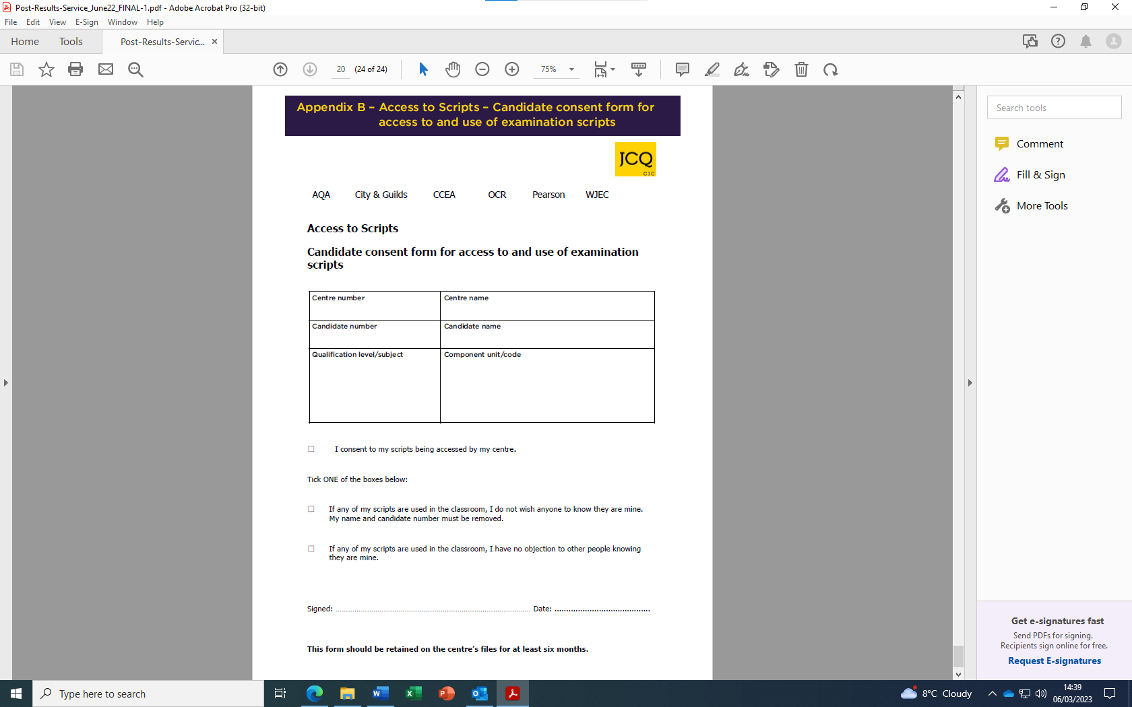

Permission for a Third-Party Collection of Exam Results/ Results being emailed

Please print and complete this section if you wish a third party to collect your results:

To: Examinations Officer

I will not be able to collect my results on results day and, therefore, give permission for

_______________________________________ (Name) to collect them on my behalf.

He/she will bring proof of identity and a copy of this notification to enable you to release my results.

Yours faithfully ________________________________________ (Signature)

_____________________________ (Student: Print Name)

*This form must be handed in on Results Day by the nominated person named above for the collection of student results (as signed above).

Please complete if you wish your results to be emailed to you:

I will be unable to collect my results in person so please can you email them to my personal email address, which will be:

……………………………………………………………………………………………………………………………..

Name ……………………………………………………………………………………………………..

Signature ………………………………………………………………………………………………………

