HMC GAP YEAR SCHOLARSHIPS
The Bulkeley-Evans HMC Scholarship Fund
www.gap-year-the-bulkeley-evans.co.uk

Administrator: Neil Mason 24 Saxon Close, Oake, Taunton, Somerset TA4 1JA.
01823 461426/07960983571 neil.mason1955@gmail.com

Applications are invited by 31st May 2024 by email (or post, if preferred) for these prestigious awards from Y13 students from HMC schools for gap year projects for 2024-2025. The Trustees have agreed that up to 30 scholarships may be awarded of between £200 and £1000.

Candidates need to fulfill the following criteria and applications must follow headings listed on the website:
- The benefit to the community of the country/countries where work is undertaken during the gap year project. The majority of awards go to boys and girls involved in projects in poorer countries or in the poorer areas of other countries.
- The suitability of the organisation of the project in terms of duration and the gap organisation involved, if there is one. The project must be of sufficient length to give real benefit to a community. The Trustees usually expect that the project will be at least for three months, unless there are special circumstances.
- Financial need, assessed from the report from the Head, the statements in the application and the breakdown of expenses and methods of raising money in the application form.
- Suitable character and promise, assessed from the quality of the written application and the reference of the Head of the school.
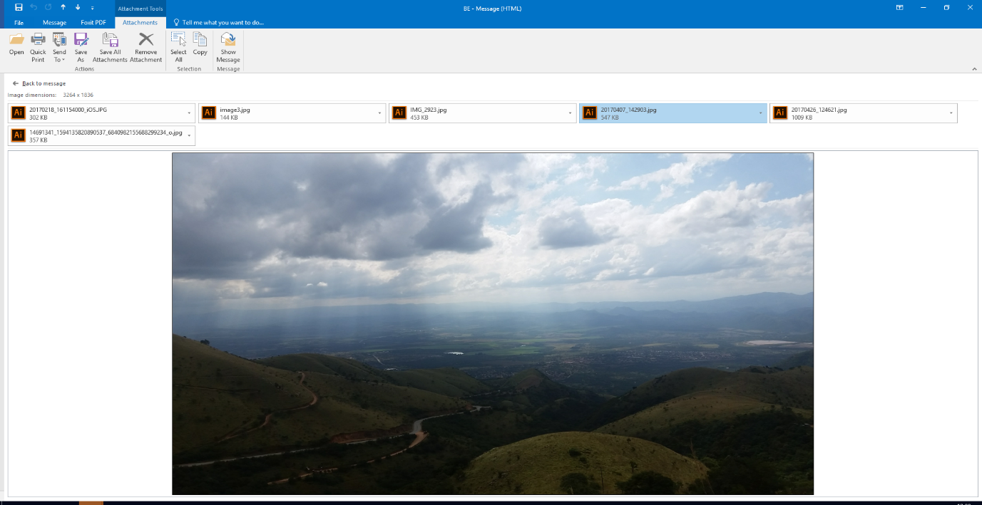
Award winners have to write to the Administrator during their project, write a report for the
Trustees at the end of their project and return to their school to talk to the Sixth Form
about their experiences.

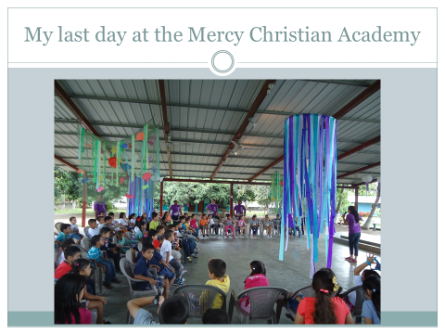
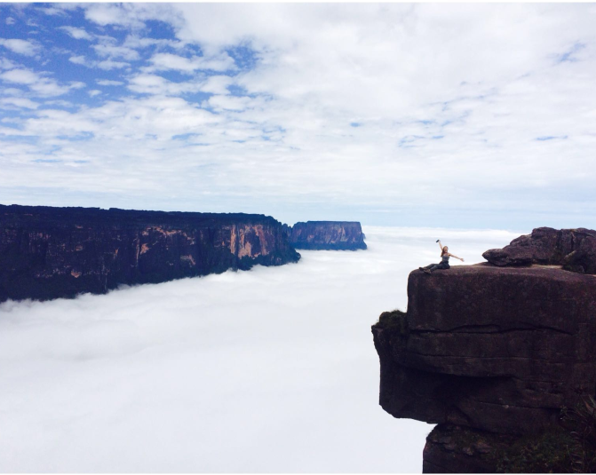

Full details can be found on the website: www.gap-year-the-bulkeley-evans.co.uk
Applicants can see the lists of previous projects that were judged to be suitable for award

Applications should reach the Administrator as soon as possible by email to: neil.mason1955@gmail.com (or post if preferred to the address above), by 31st May 2024

