Filter Tool

Please use the following tool to search for data on the weekly Vacancy Report:

Setting up the filter tool
The filter tool should already be on when you first open the weekly vacancy report. However, if you cannot see the filter option on each column of row 18 then please ensure the filter tool is turned on.
To do this:
Select cell A18
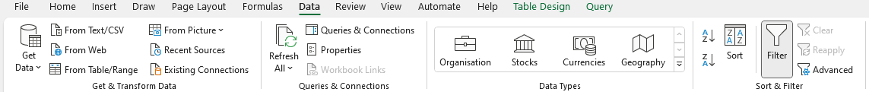
Go to Data Tab>Filter>Filter.

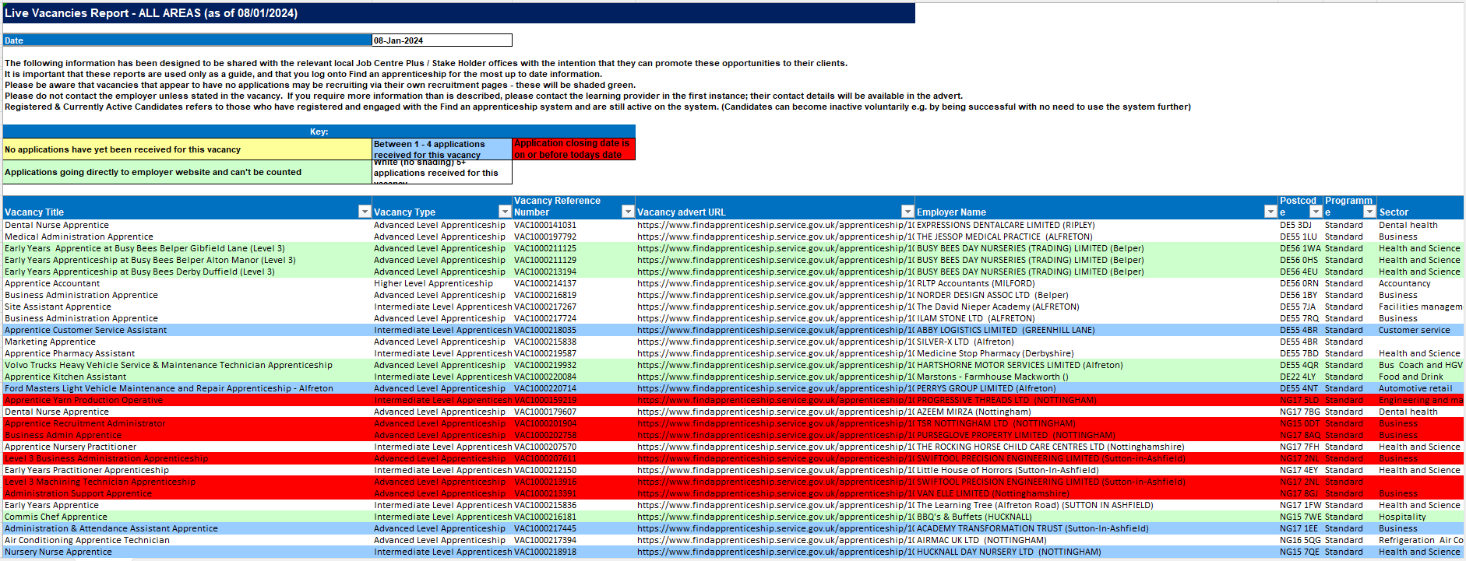
Your Spreadsheet should now look like this:

Using the filter tool
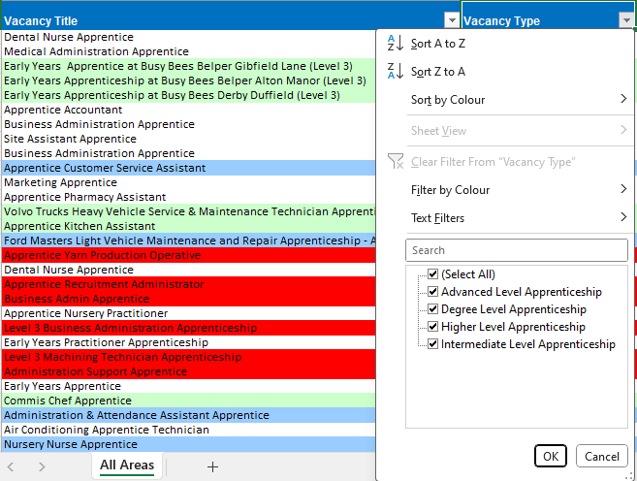
Once the filter tool is on you are now free to filter by selecting the row you would like to add a filter to by selecting the drop-down menu to launch the filter options:

Clearing the filter
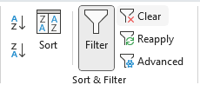
To remove all filters please go to Data Tab>Filter>Filter and select Clear. This will remove all filters applied and allow you to view the unfiltered data.

