Work Experience Guide for students

24 June- 28 June 2024

Key dates
- Introducing the concept of work experience: September 2023

- Networking and looking for placements: Autumn term 2023.

- Tutorials on writing a letter of application & CV: Dec 2023 & Jan 2024

- See Mrs Lewis for help if you haven’t found anything by the start of the Spring Term.

- Complete Grofar Stages 1 (Placement set up), Stage 2 (Validation) & Stage 3 (Set targets & objectives) before February half term 2024.

- CSW start Stage 4 (Health & Safety Checks)-must be in process before Easter 2024.

*(Placements in London or out of county may need at least 3 months to complete a health & safety risk assessment!)

- Careers South West check the placement & confirm that it can go ahead. (stage 5)

- Work experience briefings in tutorial Summer Term 2024

- Work experience takes place after the GCSEs in the week of 24-28 June 2024. You will be visited by a member of staff.

- Validate your hours worked (Stage 6) & then complete the feedback (Stage 7).

Finding a placement

- Start talking to friends, family, neighbours. Find out if any contacts you have are employed in the field of work you are interested in.

- You school friends may come in very useful! Many will have parents who work in interesting careers.

- Look for ideas on the internet, walk around your local town and see which businesses & services are nearby. Speak to the vet you use or the physio that is known to your family- personal contacts often are more willing to take you on.

- Local organisations to consider:
Exeter University labs or specific departments e.g. marketing
https://www.exeter.ac.uk/study/teachers/informationandresources/workexperience/
RD&E Hospital work experience:
https://royaldevon.nhs.uk/join-us/develop-your-career/work-experience/
MET Office:
https://www.studentladder.co.uk/job/the-met-office-work-experience-week/
Bicton College Armed Forces week (July 2024)- see application form from Mrs Lewis
Theatre Royal Plymouth:
https://theatreroyal.com/take-part/work-experience/
Exeter Museum RAMM:
https://archive.rammuseum.org.uk/getting-involved/work-experience/
Exeter Northcott Theatre:
https://exeternorthcott.co.uk/get-creative/work-experience/
Devon County Council:
https://www.devon.gov.uk/workingfordevon/work-in/early-careers/first-step/
Westcotts (Financial services)
https://westcotts.uk/careers/work-experience-placements/
Exeter Pheonix Multi Art Form Venue
https://exeterphoenix.org.uk/get-involved/vacancies-volunteering/
Exeter Airport
https://exeter-airport.co.uk/careers/work-experience-2024/
Tozers (Law firm)
https://www.tozers.co.uk/careers/work-placements
Pennon Group (South West Water)
Talent Talent@Pennon-group.co.uk
Francis Clark LLP (Accountancy, Advisory & Tax)
https://careers.pkf-francisclark.co.uk/
Michelmores LLP (Law Firm)
https://www.michelmores.com/careers/

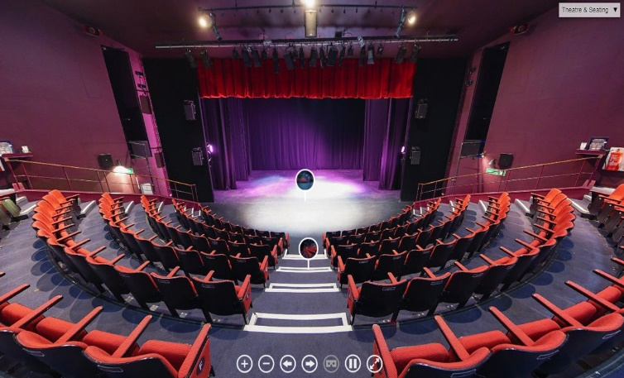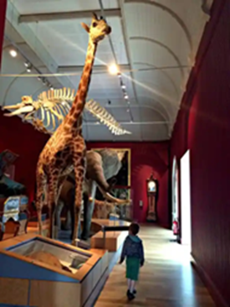

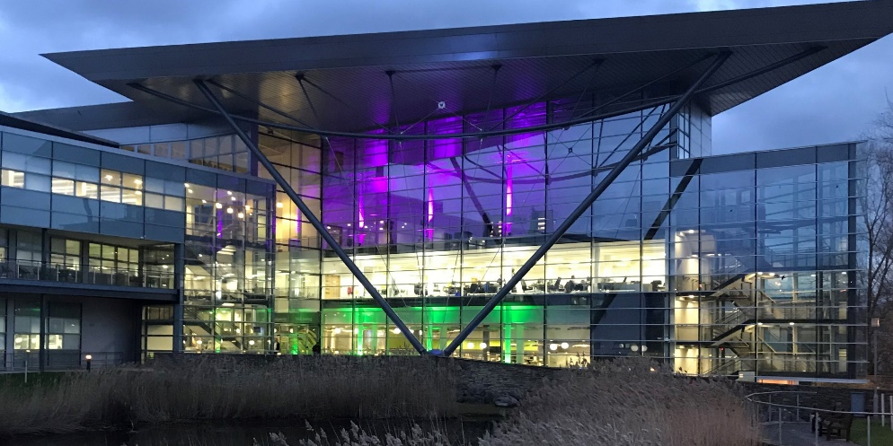

- Interested in a STEM related placement? EXIST Exeter maintains a list of organisations in and around Exeter, that work in the STEM Industries. (Look in member search) See: http://www.existexeter.co.uk/ExIST-Directory/

- Search a local business directory Devon Live maintains a local business directory, which can be searched by industry type. See: http://directory.devonlive.com/

- Look at your Grofar portal in the Businesses & Opportunities search engines- use the filters to refine your search for example by postcode location, name or job category.

*Support videos for Grofar can be found in ilearn 365/PSHE & Careers/Careers/Careers tutorials KS4/U5 Careers resources from tutorials
& on the Grofar Student support hub: https://support.grofar.com/hc/en-us

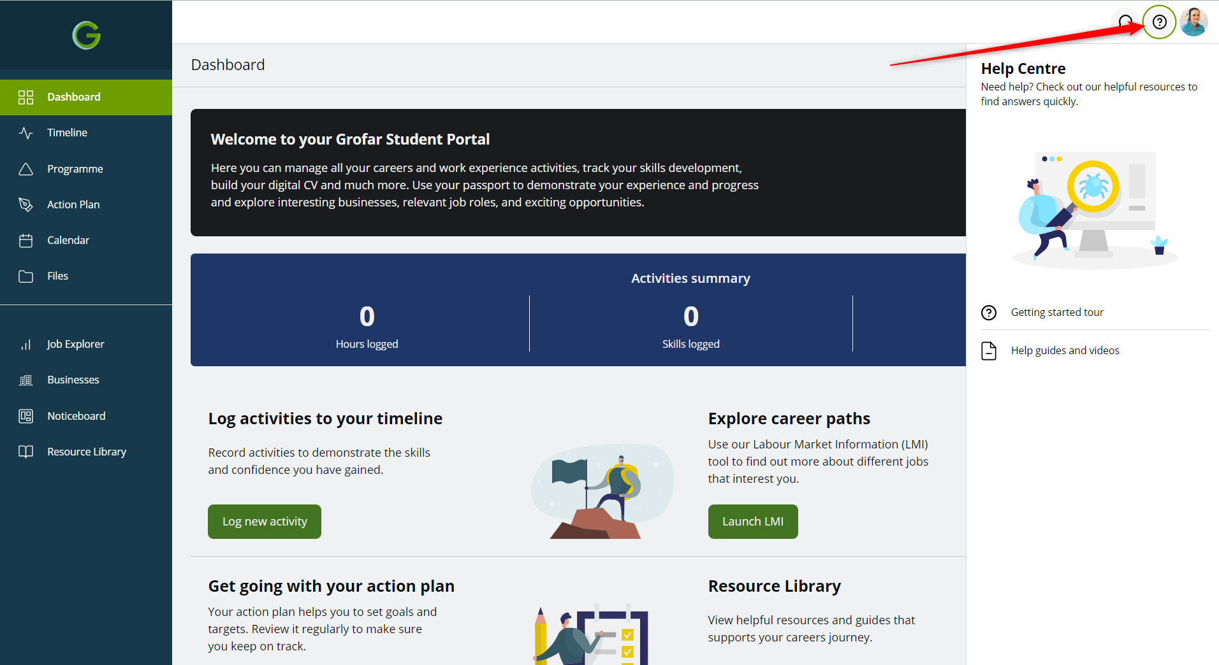

- If you are struggling speak to your form tutor or Mrs Lewis for ideas. In addition subject teachers may have insights into careers around their subject areas.

- Once you have an employer in mind you will need to write a letter of application and possibly a Curriculum vitae (CV). We will cover this in tutorial lessons. The PowerPoint and resources to accompany tutorial lessons can be found in ilearn/ PSHE & Careers/ Careers tutorials KS4/Upper 5 careers resources.

Confirming your placement

https://support.grofar.com/hc/en-us

Grofar: The 7 stages of executing a work placement

Stage 1: Placement Setup
- A new placement is created by the student either through the ‘Opportunities’ section of the platform or students can submit their own placement forms if they've found somewhere they'd like to complete their work placement.
- To complete stage 1, the placement form needs to be completed with all the placement details (see below)

How to enter your placement details
1. Once you have logged in, tap 'Placements' in the menu.
2. Tap the edit icon to add details to your placement form.
3. Enter the details of your placement on the next page. Please complete as much information as possible.
To be able to submit your placement details, you must provide:
- The job title (what role will you be doing on placement)
- The name of the business
- The address and postcode of the business
- Contact details of the main contact at the business during your placement
- The details of someone who can be contacted in an emergency during your placement.
When you reach the end of the placement form, please read the information in the confirmation box and tap 'Submit' (you can also tap 'Save as Draft' if you need more time to gather the essential information).
After you tab submit, your coordinator will be notified. They will check the details of your placement and let you know when you can begin your placement.
*It's worth contacting the business before adding their details to a work placement so that when they are invited to accept a placement, they already know the request is coming.

Stage 2: Placement Validation
Once the placement details are agreed by the Mrs Lewis an automatic email will go to the business and parent/carer requesting them to accept the work placement through an online form.

Stage 3: Targets and Objectives
- Once a placement is confirmed, targets need to be set. Targets can be saved in a draft state, in the student portal in the 'Goals and Targets' section.
- Mrs Lewis must then review these targets in Grofar and set them to 'Agreed'.

Stage 4: Health and Safety and other checks
- Once a business accepts a placement, the placement will be listed in the 'Health and Safety' section of Grofar, showing which health and safety checks need to be completed.
- Health and safety checks include - 'Health and Safety Confirmation', 'Higher Risk Assessment' and 'DBS check'.
- If your placement is out of county you will be asked to complete an ‘Additional Risk Assessment Form’ (see below) to let us know where you will be staying during your placement and your travel plans.
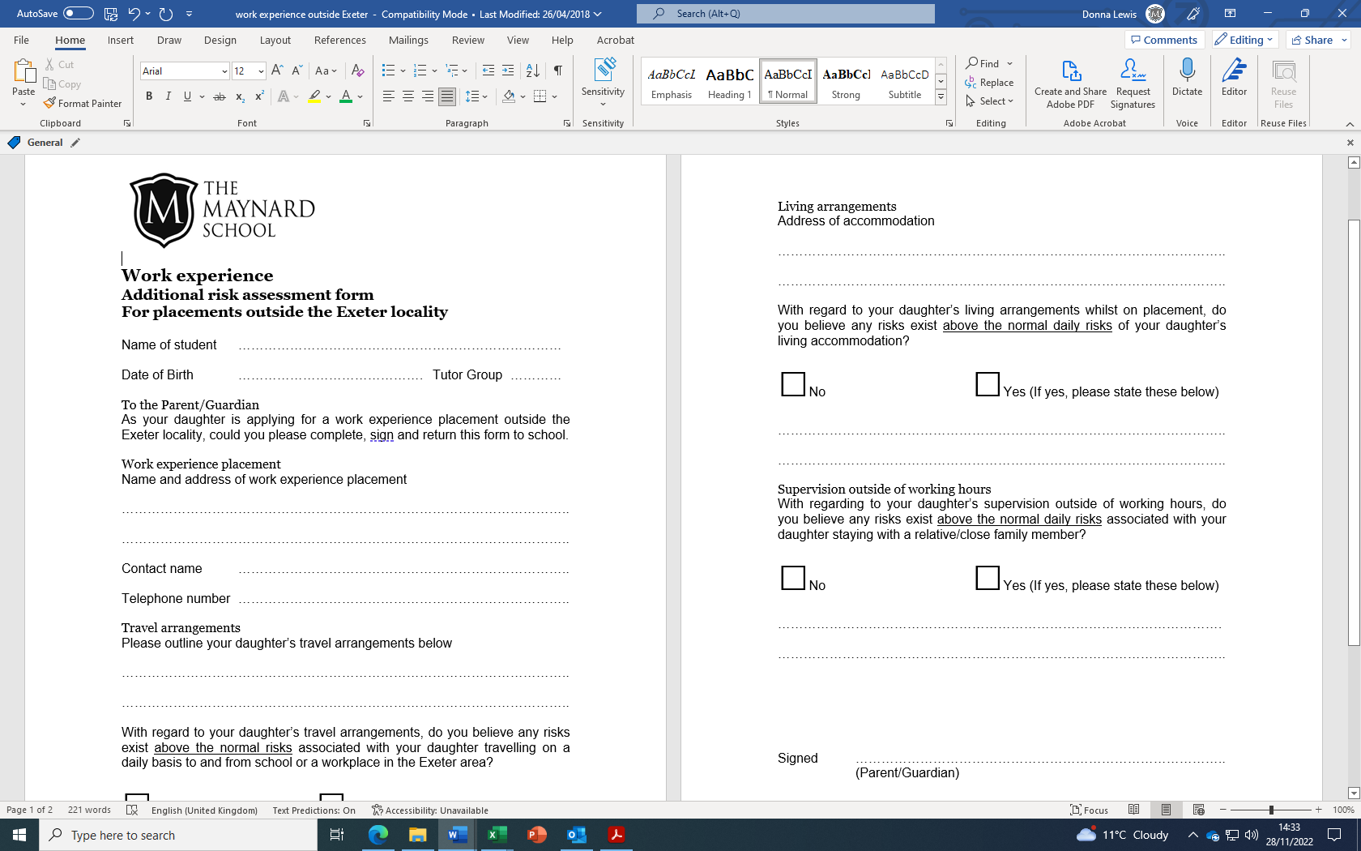

Stage 5: Placement Confirmation
- Once the Health and Safety checks are complete, there is an automatic notification to BOTH business and student confirming placement details.

Stage 6: Validating Hours
- STUDENTS: the student will log the hours they have worked and the experiences they had which help them reach their targets for the placement. This is done by the student via the Student Portal.
- BUSINESSES: The business validates student hours each week via the summary email they receive. This email lists each student that has logged hours that week which they then confirm..

Stage 7: Review and Feedback
A placement end date must have passed for the placement to enter stage 7
- STUDENTS: In the Student Portal, they should complete the feedback section for their placement - this goes to Mrs Lewis to review.
- BUSINESSES: Receive an email with a link to an online feedback form which, when complete, is sent to Mrs Lewis.

Preparing for work experience in the Summer Term

Once you have all secured your placements, the attention can turn to preparing for the reality of work.

In the final weeks of the summer term, before study leave, you will be issued with a work experience log book. In tutorial time we will discuss Health and Safety, and the expectations of employers. We will also cover what to wear, what to do if you are ill or running late etc. There will be time for last minute questions and queries.

During work experience week you will be visited or called by a member of staff. If you cannot be reached email messages might be sent. Should you be worried about anything at all you should contact the school, who will pass on your concerns to Mrs Lewis.

Upon your return to school, you will be debriefed in the first few weeks of the L6 and evaluate your experiences. You may be asked to talk to the U5 about your placement & offer any tips you might have. We encourage all students to send Thank You cards to your placements.

