August 2024 Our ref: LG/DL/lm

Dear GCE Student

GCE EXAMINATION RESULTS

It must seem like a long time since you took the examinations – but here, at last, are your results! I hope that you are pleased with your achievements, but if you have any concerns, please discuss them with Mr Hibberd, Mrs Lewis or myself.

There are some important administrative points that you need to be aware of at this stage:

- Any questions you may have about your results or university placements should go direct to Mr Hibberd without delay and he will advise you on the various options available. You should note that if you ask to have the mark of any of your papers reviewed, the grade that you have obtained might be revised to be a higher grade or a lower grade than the one that you have now. You will need pay in the school finance office by card or over the phone on 01392 355990 for post exam services when you request them. (Details of the costs and services available and the link to request post exam services can be found on the information letter enclosed).

- You have the option of asking to see your written scripts. This may be purely for your own interest, or in connection with a possible enquiry of results (see Mr Hibberd, as indicated above). It is often useful for your subject teachers to look over your scripts to see if a review of results is a viable option, before requesting this service. If you wish to have any scripts returned, you should complete this electronic form https://forms.office.com/e/X0LGyazxvk . The form can also be found on the school website in the Examination Information section.

- Teachers may like to use your scripts to help them prepare candidates for future examinations. If you agree with the staff using your script, please complete the form to request access to scripts, putting N/A in the subject sections.

- Exam certificates arrive in school during October/November. You must arrange to collect your certificates in person from the school from November 2024 onwards. Please inform Mrs Lewis (Donnalewis@maynard.co.uk) prior to collection, so that they can be left in Reception. If you cannot collect them personally, you will need to give written consent for a third party to collect on your behalf. Certificates can only be retained within school for one year, so please try to collect them as soon as you can.

My very best wishes for the future.

Yours sincerely
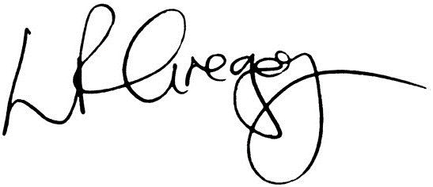
Mrs Gregory
Head

